Practice work #2
At the first lesson we installed yocto-linux at our sd cards and tested how it works. At this lesson we are going to use library mraa for creating “hello world” and blink LED via linux, instead of Arduino. All links and source codes you can find on github:
- If you have not UART, you will plug in Ethernet-cable and use this sketch: Use Putty at COM of Galileo. Write ifconfig and find ipv4 address.
- Connect via Putty using ipv4 address or COM (if connected via UART).
We have connected to yocto and let`s turn on WiFi.
- Check you WiFi connection (use: ifconfig).
- Connect to WiFi
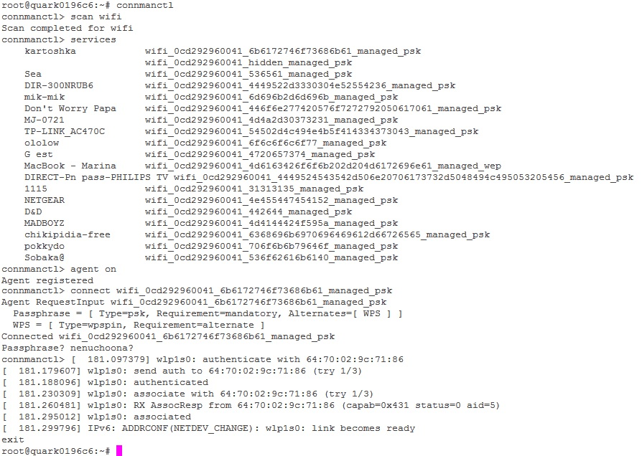

Let us consider how to work with mraa library:
- Firstly, update mraa:
echo "src maa-upm http://iotdk.intel.com/repos/1.1/intelgalactic" > /etc/opkg/intel-iotdk.conf
opkg update
opkg upgrade

- Create txt file on your PC and give a name with extension .cpp . Copy the next code for hello world:
#include "mraa.h"
int main(int argc, char** argv)
{
char* board_name = mraa_get_platform_name();
fprintf(stdout, "hello mraa\n Version: %s\n Running on %s\n", mraa_get_version(), board_name);
mraa_deinit();
return MRAA_SUCCESS;
}

- Upload your new file via pscp. How to use(windows):

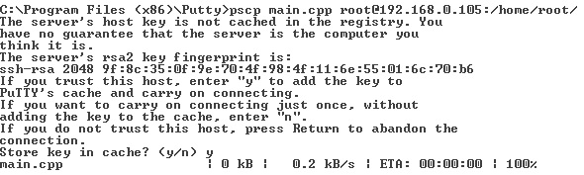

- For compile and execute you can use the following commands:

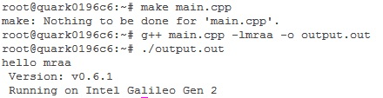

- Compile and execute code for Led blink (led.cpp).
- Connect analog sensor, and using code sensor.cpp for get data from device.

